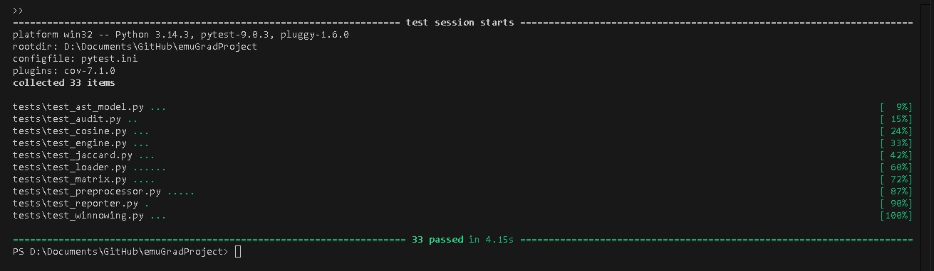
1. .\plagcheck\venv\Scripts\python.exe -m pytest tests\

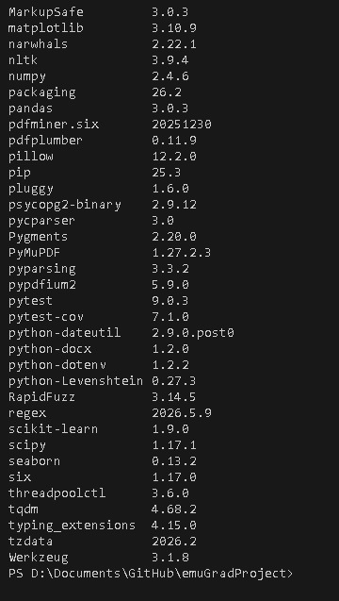
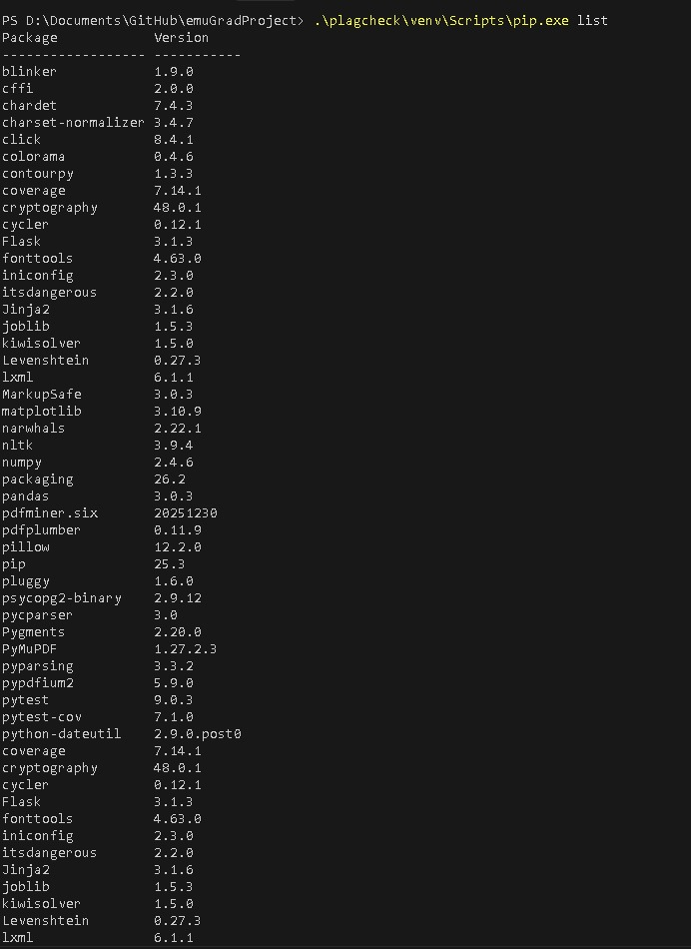
2. .\plagcheck\venv\Scripts\pip.exe list

3. tree /f plagcheck
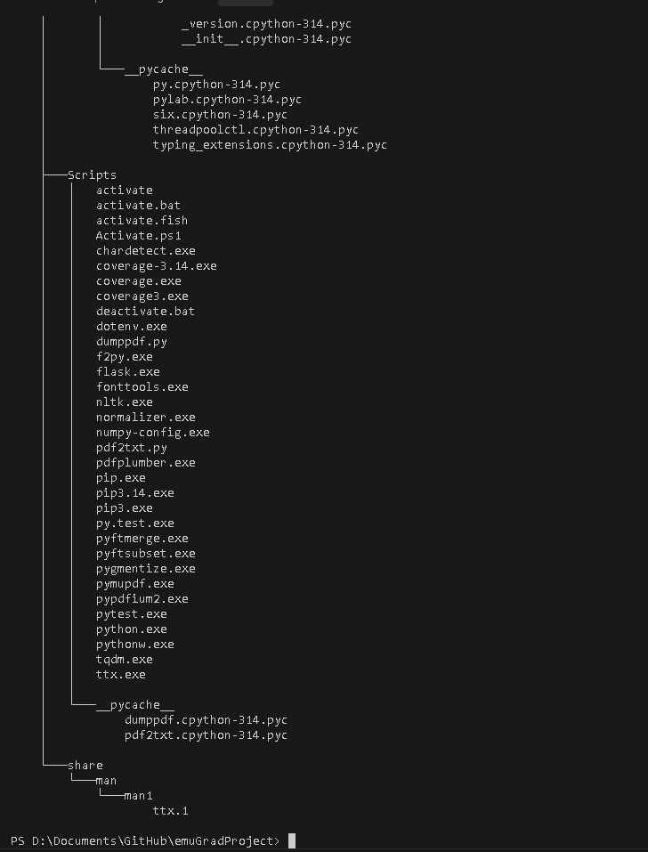

4. git log --oneline -n 5
